**Answer**

**Objective Question**

Q 1) What is the total no. of tables present in the data?

Ans. 1) The given Excel workbook has two tables: one in the raw data section, which contains the details of restaurants, and another in the country description section, which includes details regarding the country and its code.

Q 2) What is the total no. of attributes present in the data?

Ans. 2) There are a total of 24 attributes present in the data.

Q 3) How many categorical columns are there in the data?

Ans. 3) There are 20 columns in the table which is in the Raw data sheet and 2 columns in the table which is in the country description sheet.

Names of the columns are as follows:-

RestaurantID, RestaurantName, CountryCode, Country, City, Address, Locality, LocalityVerbose, Longitude, Latitude, Cuisines, cusines_updated, Currency, Has_Table_booking, Has_Online_delivery, Is_delivering_now, Switch_to_order_menu, Price_range, Votes, Average_Cost_for_two, Rating, Datekey_Opening, Datekey_opening_year, Datekey_Opening_updated, average cost in INR CUSTOMIZED_PRICE

Q 4) The data consists of some inconsistent and missing values so ensure that the data used for further analysis is cleaned.

Ans. 4) To address missing and inconsistent data, we used the Find and Replace function. Nine blank cells in the "Cuisines" column were filled with the default value "Spicy Food" in a new column, "Cuisines_Updated," without modifying the original data. Additionally, the "DateKey_Opening" column had an incorrect date-time format, so we created a new column, "DateKey_Opening_Updated," and converted the values to the correct date-time format. This approach ensured data integrity while making necessary updates.

Q 5) Using the Lookup functions, fill out the countries in the original data using the country code.

Ans. 5) **=VLOOKUP(C2,'country description'!$A$1:$B$16,2) )**.

Q 6) Create a table to represent the number of restaurants opened in each country.

Ans. 6)

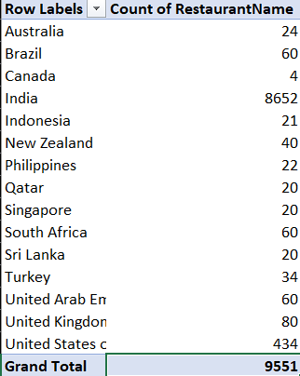

Q 7) Also, the management wants to look at the number of restaurants opened each year, so provide them with something here.

Ans. 7)

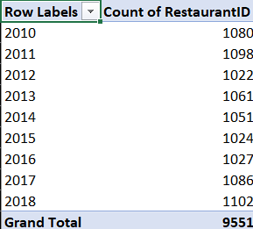

Q 8) What is the total number of restaurants in India in the price range of 4?

Ans. 8) There are a total of 388 restaurants present in India with a price range of 4.

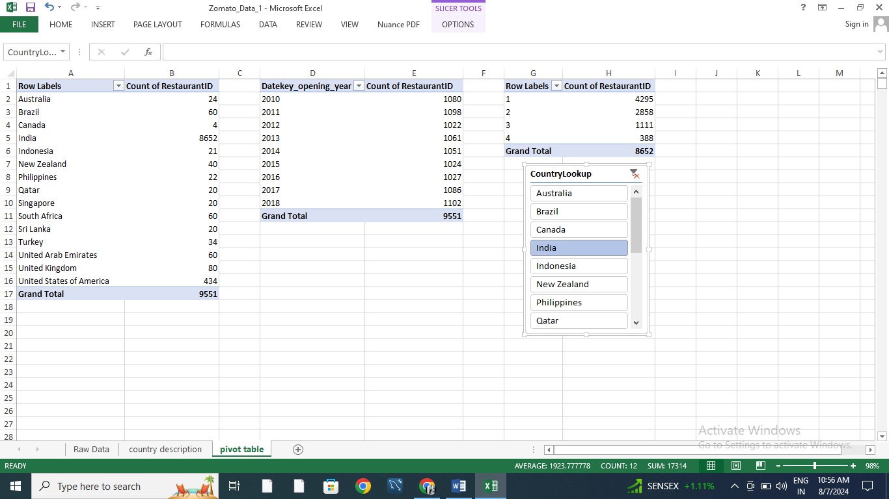

Q 9) What is the average number of voters for the restaurants in each country according to the data?

Ans. 9)

|  |  |
| --- | --- |
| **Row Labels** | **Average of Votes** |
| Australia | 111.4166667 |
| Brazil | 19.61666667 |
| Canada | 103 |
| India | 137.212552 |
| Indonesia | 772.0952381 |
| New Zealand | 243.025 |
| Philippines | 407.4090909 |
| Qatar | 163.8 |
| Singapore | 31.9 |
| South Africa | 315.1666667 |
| Sri Lanka | 146.45 |
| Turkey | 431.4705882 |
| United Arab Emirates | 493.5166667 |
| United Kingdom | 205.4875 |
| United States of America | 428.2211982 |
| **Grand Total** | **156.9097477** |

Q 10) Calculate the average rating for all the restaurants that have price range < 4 and provide online delivery. Use only the “IF” function, Logical Operators, and Aggregation functions to solve this problem.

Ans. 10) Average rating for all the restaurants that have price range < 4 and provide online delivery = 3.27381151

Formula: -

I got an average rating as **3.27381151**, I have used the formula:

“**=AVERAGE(IF(('Raw Data'!R2:R9552<4)*('Raw Data'!O2:O9552="Yes"),' Raw Data'!U2:U9552))”** to the average rating.

Q 11) Using Conditional formatting highlight the rows of restaurants that are located in the countries or cities that you’ve suggested to the management for opening new restaurants.

Ans. 11)

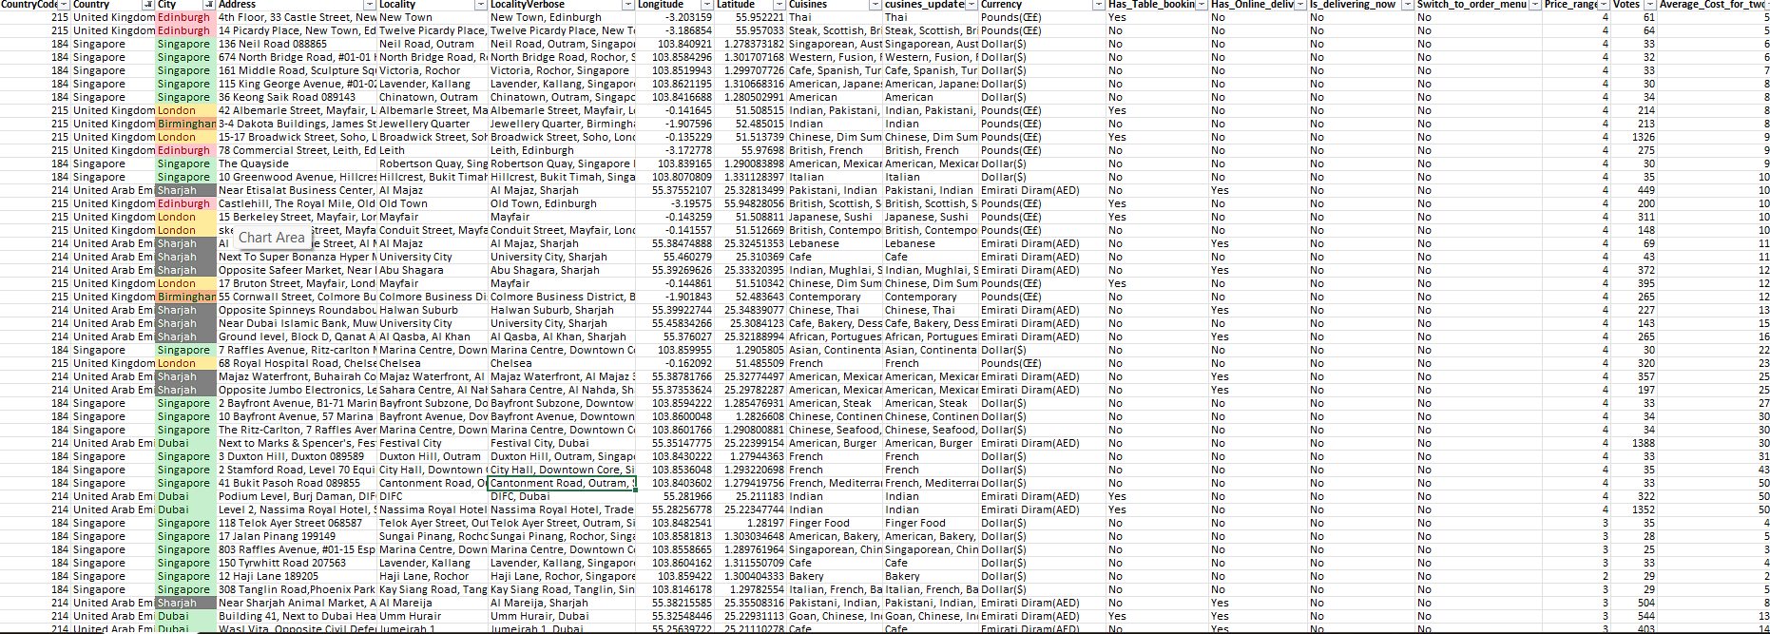

Q 12) Create a new customized price column that consists of the abbreviation/symbol of the currency along with the Average_cost_for_two value.

Ans 12) We use TRIM function along with MID and FIND function in the new column created named as customized price.

**Formula:** **=TRIM(MID(M2, FIND("(", M2) + 1, FIND(")", M2) - FIND("(", M2) - 1)) & T2**

Q 13) How can you create an array formula in Excel or Google Sheets to count the number of restaurants listed that do not offer online delivery, are in the lowest price range, and have an average cost for two people less than or equal to 250 Indian Rupees?

Ans. 13) After applying the array formula combining SUM and IF conditions, we identified 1,685 restaurants where the average cost for two people is less than or equal to Rs. 250, do not offer online delivery, and fall within the lowest price range.

**FORMULA: (*Here we use array formula) :-*=SUM(IF((O2:O9552="NO")*(R2:R9552=MIN(R2:R9552))*(Y2:Y9552<=250),1,0))**

**Subjective Answer**

Q 1) Suggest a few countries where the team can open newer restaurants with lesser competition. Which visualization/technique will you use here to justify the suggestions?

Ans) In my opinion we can open several luxurious restaurants in countries like –

1. United Arab Emirates
2. Singapore
3. United Kingdom

Insight: -

* **The United Arab Emirates** has only 60 restaurants. These numbers are significantly lower than in other countries, such as India, with over 8,600 restaurants.
* **Singapore** has 20 restaurants, reflecting a balance between online and table bookings and relatively high customer satisfaction.
* **The United Kingdom** has 80 restaurants with an average rating of 4.01, reflecting a balance between online and table bookings and relatively high customer satisfaction.

**Recommendation:**

* Because there are fewer luxurious restaurants in these countries, people are coming to these countries for vacations and to spend money on good-quality food and hotels. We can open restaurants there.
* The rating of restaurants is good in the suggested countries.
* All these countries have varieties of cuisines in the 1 to 4 Price range.
* The number of restaurants providing online delivery is very low.
* The number of restaurants providing table booking is very low.

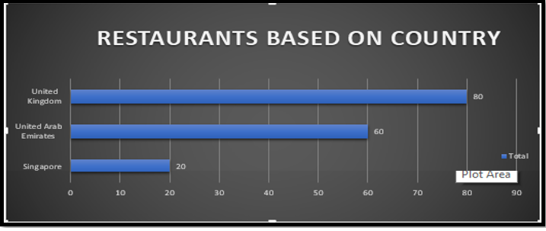

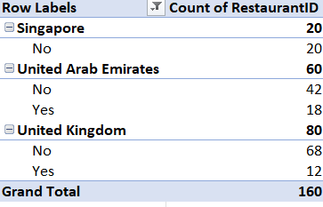

Table for Has_Table_Booking.

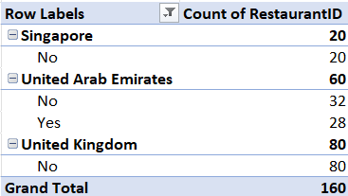

Table for Has_Online_Delivery.

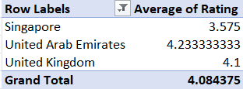

Q 2) Come up with the names of States and cities in the suggested countries suitable for opening restaurants.

Ans) In the suggested countries we can open restaurants in these cities-

1. Birmingham
2. Dubai
3. Edinburgh
4. London
5. Sharjah
6. Singapore

**Recommendation**:

**1 Target Countries:**

* **Singapore**, **United Arab Emirates**, and **United Kingdom** are recommended due to their low current restaurant count.

**2 Favorable Market Factors:**

* These countries show **good ratings** for existing restaurants.
* A **variety of cuisines** is offered within the **1 to 4 price range**, catering to diverse customer preferences.

**3 Opportunity in Online Delivery:**

* The number of restaurants providing **online delivery** is significantly low, offering a potential to capture this underserved market segment.

**4 Market Appeal:**

* The combination of **high ratings**, **diverse cuisines**, and the **affordability** range enhances their attractiveness for investment.

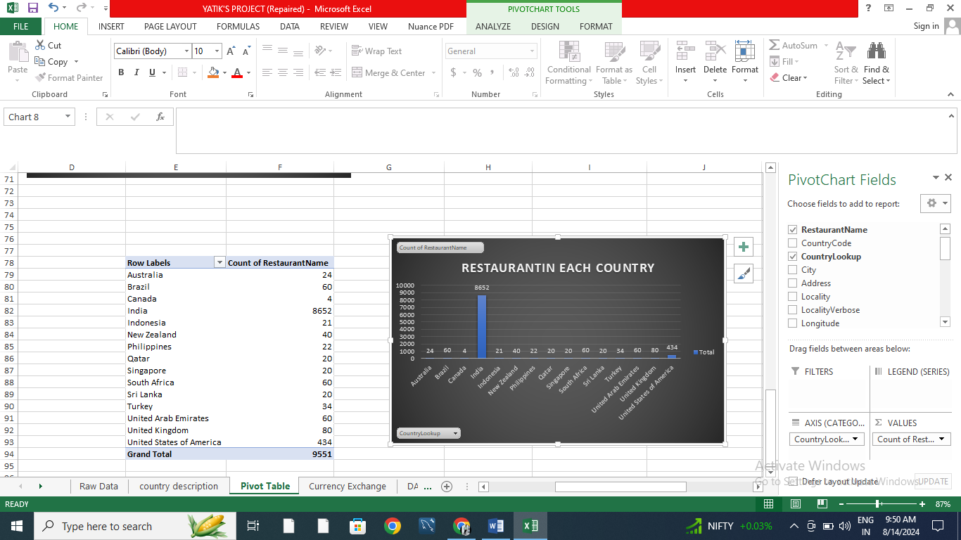

**Insights:**

* **Birmingham** has only 1 restaurant. This suggests that competition is low and that there is an opportunity for new restaurants.
* **Edinburgh** has only one restaurant, making it an ideal location with minimal competition. The average rating of 3 suggests room for improvement, offering an opportunity to introduce new dining experiences.
* **London** has 1 restaurant, the consistent average rating of 3.4 indicates steady demand. This presents an opportunity for new entrants to differentiate themselves with unique offerings.
* **Sharjah** has only one restaurant with a low moderate rating of 3.3, This creates an opportunity for a new restaurant to capture the market by offering a superior dining experience.

Q 3) According to the countries you suggested, what is the current quality regarding ratings for restaurants that are open there?

Ans) **Suggestion-** In the suggested countries for opening new luxury restaurants, the ratings of those that opened in the past are generally very high, with restaurants in all countries having ratings of 4.0 and above, except for Singapore. However, we can manage this, as Singapore is one of the most visited tourist destinations, and its infrastructure is renowned, particularly for its restaurants, beaches, and ports.

1. Singapore
2. United Arab Emirates
3. United Kingdom

**Approach:** We filtered the database to focus on Singapore, the United Arab Emirates, and the United Kingdom. Using a Pivot Table, we calculated the average rating for restaurants in each of these countries. A corresponding chart was then created to visually represent the average ratings, providing a clear comparison of restaurant performance across the selected countries.

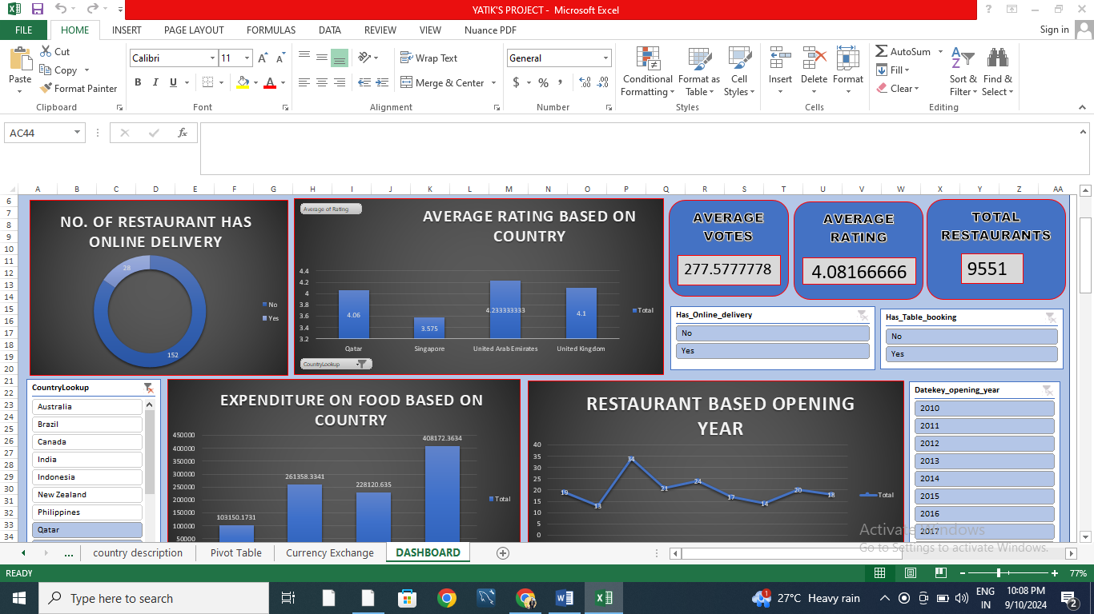

Q 4) What is the current expenditure on food in the suggested countries, so we can keep our financial expenditure in control?

Ans ) Looking at the current expenditure on luxury foods and their cost in INR across the suggested countries—**Singapore, the United Arab Emirates, and the United Kingdom**—provides valuable insights into market trends and customer spending behavior.

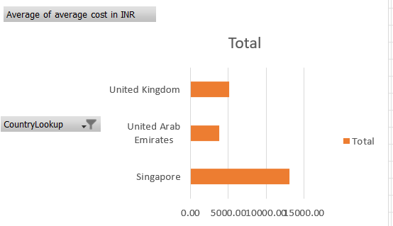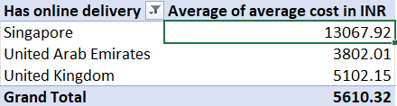

**Approach**: We filter the database to focus on Singapore, the United Arab Emirates, and the United Kingdom. The currency is then converted into Indian Rupees (INR) for consistency. Using a Pivot Table, we calculate each country's total expenditure on food. A corresponding chart is created to compare the food expenditure across these countries visually. This approach offers a clear, comparative view of food spending in different regions.

Q 5) Come up with the names of restaurants from the recommended states that are our biggest competitors and also those that are rated in the lower brackets, i.e. 1-2 or 2-3.

Ans) **Approach:** In the suggested countries—Singapore, United Arab Emirates, and the United Kingdom—none of the restaurants have ratings in the lower brackets of 1-2 or 2-3. This indicates that the restaurant quality in these regions is consistently above average, making them promising locations for potential expansion or investment.

**Insights:**

In the below data these restaurants name for good competitors in the market.

**Recommended:**

Tresind – Nassima Royal Hotel stands out with the highest rating above 4. None of the suggested countries have a concentration of the lowest-rated restaurants. Prioritizing quality and delivering a unique dining experience can effectively capture a larger market share and contribute to increasing the average cost per customer.

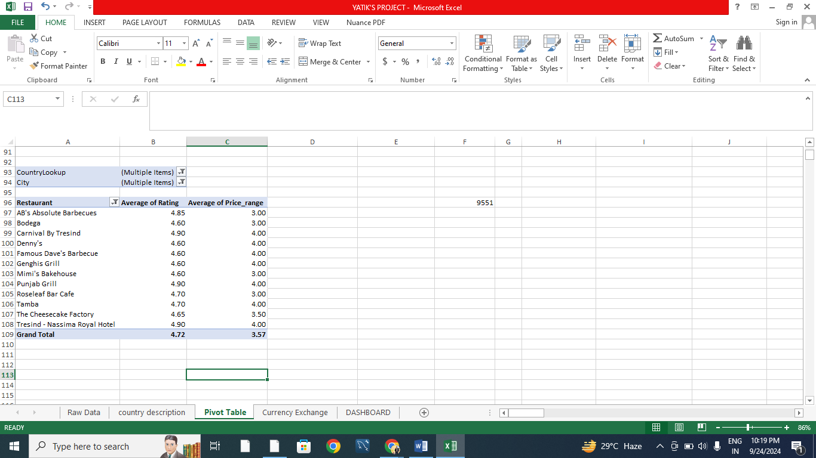

Q6) Which cuisines should we focus on in the newer restaurants to get better feedback? Does the choice of cuisines affect the restaurant ratings?

Ans) **Approach:** Cuisines with good ratings, i.e., those already performing well in the selected countries, can be introduced in new restaurant branches to ensure strong revenue generation from the start. This strategy leverages the popularity of well-received cuisines to attract initial customers. Over time, local cuisines can also be introduced to meet future customer demands and cater to regional tastes, ensuring sustained growth and customer satisfaction.

**Insights:**

1. Restaurants in Abu Dhabi and Agra serving Asian, Chinese, Italian, and north Indian cuisine are only receiving average ratings.
2. Doha is receiving average ratings in almost all the cuisines available.

**Recommendation:**

Turkish, Chinese, and Italian cuisines currently have lower ratings. Focusing on providing authentic Chinese cuisine paired with a unique dining experience can help capture the market. Similarly, fast food is rated average across global cuisines, emphasizing the need to prioritize authentic food and an enhanced dining experience to improve customer satisfaction.

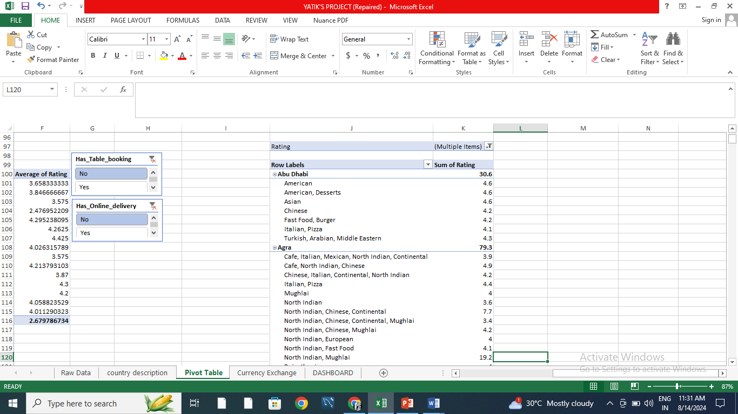

Q7) According to our current data, should we go for online delivery and table booking? Does that affect the customer’s ratings?

Ans) Restaurants offering both online delivery and table booking services show an increase in ratings. This suggests that these features positively influence customer ratings and satisfaction.

**Recommendations: -** Include features of online delivery and table booking for the ease of the customer.

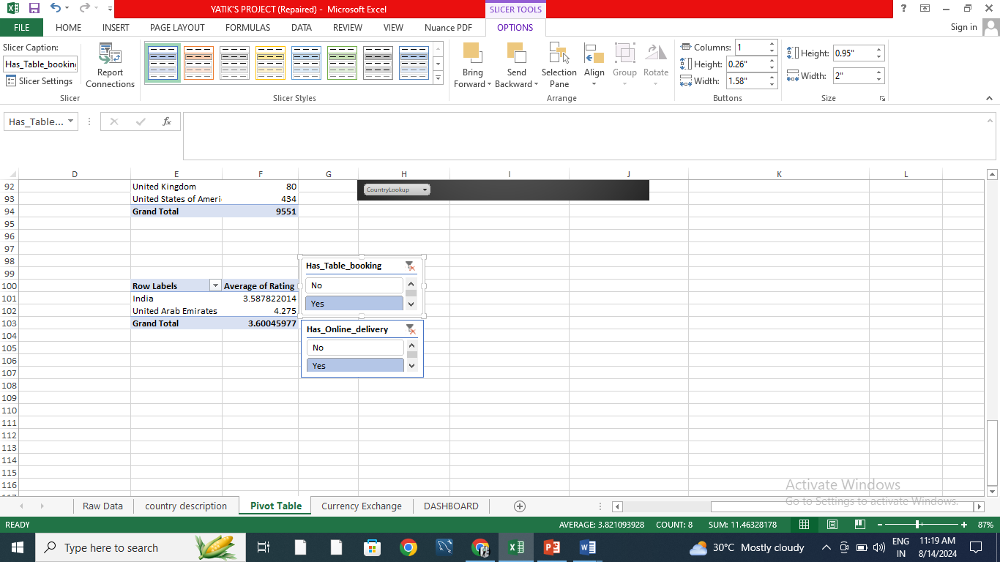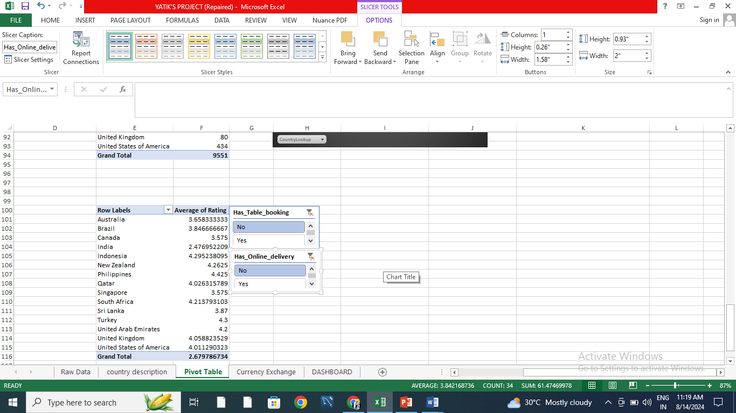

Q8) Should the team keep the rate of cuisines higher? Will that affect the feedback? According to our data are the rates of cuisines and ratings, correlated?

Ans) **Insights:** The linear forecast trend line shows a slight upward movement, and the correlation coefficient approaches +1. This indicates a positive correlation between cuisine rates and ratings, meaning that as one variable increases, the other tends to increase as well.

**Recommendation:** Insights from the data should not lead to a blanket increase in the price of every cuisine in every country to achieve better ratings. Instead, we should analyze a country-wise scatter plot comparing ratings and average prices. This approach helps identify where pricing adjustments are feasible and supported by local market conditions. Prices should only be increased in countries where the data indicates that higher prices align with better ratings and customer acceptance.

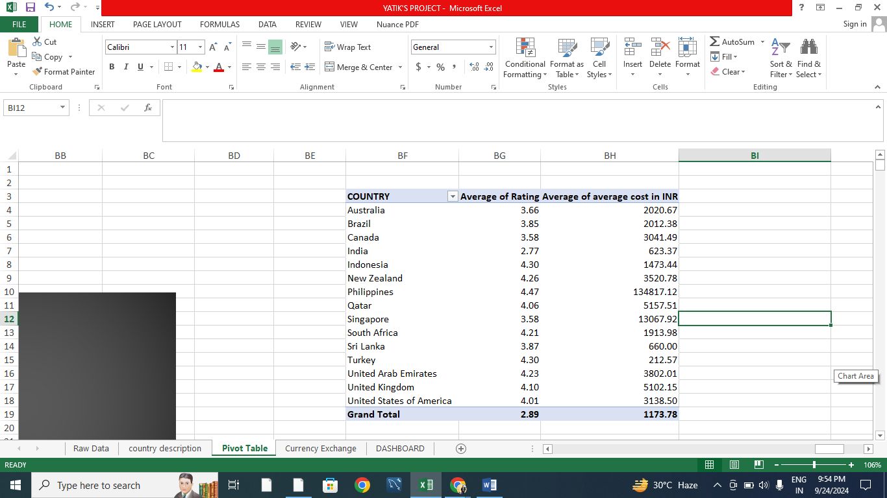

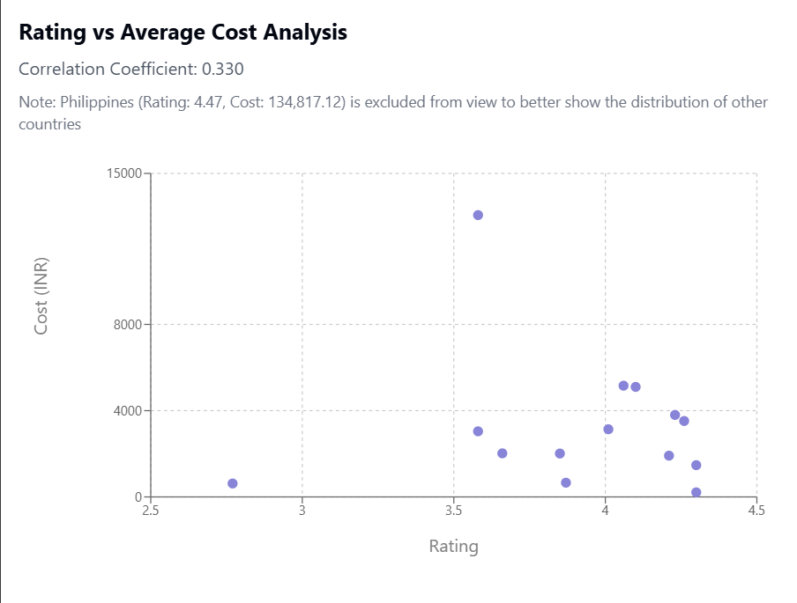

Q9) What is the distribution of the number of restaurants of different price ranges in all the countries?

Ans) **Approach:** Different countries exhibit varying distributions of restaurants across price ranges. India stands out with the highest number of restaurants across all price ranges, indicating a robust market presence. In contrast, countries like the United States, United Kingdom, and South Africa show a more balanced distribution of restaurants across price ranges but with significantly lower totals compared to India. Meanwhile, countries such as Indonesia, Sri Lanka, and Qatar have the fewest restaurants, highlighting potential opportunities for market expansion in these regions.

**Insights:**

Over 4,000 restaurants fall within the price range of 1, indicating that the majority offer an affordable dining experience. Conversely, only a few restaurants fall within the price range of 4. The number of restaurants steadily decreases as the price range increases, likely due to the higher costs associated with premium offerings.

**Recommendation:**

1. Opening restaurants in the price range of 1-2 would help us attract a large clientele since we know that majority of the market is between these ranges.
2. Opening restaurants in higher price range like 3-4 would cater to a small audience, offering unique and special dining experience with good quality food may help attract this clientele as they are willing to pay for better experience.



Q10) Explain your approach in brief for suggesting countries/cities in order to open new restaurants.

Ans)

1. Identify countries and cities through a strategic analysis of restaurant density. Focus on entering markets with lower restaurant density to minimize direct competition and maximize the potential for establishing a strong market presence.
2. Focusing on cities where the average cost for two is high indicates a higher spending capacity among customers. This presents an opportunity to introduce affordable yet high-quality food options, catering to a broader audience while maintaining value.
3. Target cities, restaurants, and cuisines with higher ratings compared to others, as they indicate strong customer preferences and satisfaction, providing valuable insights for market entry and positioning.
4. Focus on countries that offer both online delivery and table booking services, as these features significantly enhance restaurant sales and customer convenience